PRESS RELEASE
24 OCTOBER 2018

HB Reavis and Morley College London launch new exhibition 'Past, Present and Future of Waterloo’ at Elizabeth House

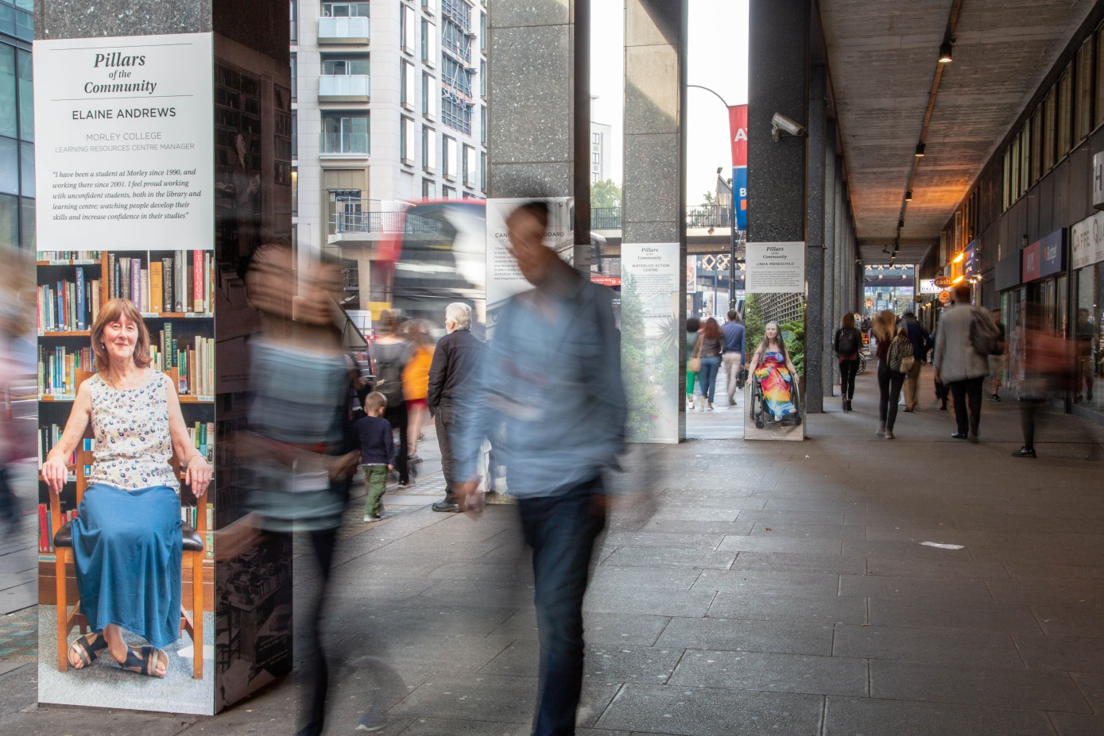
HB Reavis, the international workspace provider, and Waterloo-based Morley College London, one of the UK’s leading centres for adult education, have launched their collaborative ‘Past, Present and Future of Waterloo’ art exhibition at Elizabeth House.

The project will transform the colonnade on York Road, underneath the 1960s building, into a public art gallery with displays of imagery, artwork and textiles, bringing the area surrounding Elizabeth House to life.

The first phase of the exhibition sees five colonnade pillars dressed with imagery taken by Morley students and Digital Media and Photography Programme Manager, Steve Mepsted. The works, named ‘Pillars of the Community’, showcase the history of the area and include images of local people who have helped shape the landscape of Waterloo. The series includes photographs of Giles Goddard, the Vicar of St Johns Church Waterloo; volunteers from the Waterloo Action Centre; Elaine Andrews, Learning Resources Centre Manager at Morley College; and historic archive imagery.

In addition, the ‘Past, Present and Future of Waterloo’ project will see a further collection of decorated columns popping up with mosaics, paintings, drawings and ceramics created by Morley students. The project aims to highlight the area’s rich heritage and create an enlivened space for those working, living in and visiting the area.

There is also a carefully curated window display installed at Elizabeth House, showcasing the work undertaken by textiles and jewellery students at the college. The display includes a range of pieces from Morley students.

The collaboration with Morley College London is part of HB Reavis’ shorter-term plans to activate the building and surrounding area, in advance of the longer term plans to redevelop the site. In addition to enlivening York Road with public artwork, HB Reavis’ plans include the introduction of new retailers to add to the current offer. This includes welcoming the return of the much loved café Love and Scandal, who were previously in Lower Marsh, as well as the expansion of other independent Waterloo based enterprises: the Garden Shack, who specialise in selling indoor and outdoor plants, and a local coffee shop, Four Corners.

In addition they welcome LLS Café, who offers healthy and ethically produced deli-style food; handmade doughnut specialist, Crosstown Doughnuts; and Pancs, who provide sweet and savoury handcrafted pancake-wraps.

Adding to this, Sara Robertson-Jonas, Head of School for Visual and Digital Arts, Morley College London, said:

“Morley College London is delighted to partner with HB Reavis and have this opportunity to engage with the local neighbourhood and showcase the creativity of our students. We look forward to injecting new life into Elizabeth House through our partnership and bringing the work of our students to wider audiences.”

HB Reavis purchased Elizabeth House in May 2017. They have since appointed Stirling Prize-winning architects Allford Hall Monaghan Morris (AHMM) as design partner, to bring forward fresh proposals for the site that focus on replacing the outdated existing building with new work space and supporting the ambition of delivering approximately 13,000 new jobs for the area, as well as transforming the public space and pedestrian experience around the site.
The Morley College London exhibition runs until Winter 2019.

- End –

Notes to Editors

Contacts for the media

HB Reavis;
Amy McIlwraith
Marketing Manager – UK and Group
Email: Amy.McIlwraith@hbreavis.com
M +44759 883 9789
T +207 621 9334
Declan Bennett
London Communications Agency
E-mail: db@londoncommunications.co.uk
Tel.: 020 7291 1504
M: 07952835328

Morley College London:

Leah Holmes, PR and Marketing Officer Leah.Holmes@morleycollege.ac.uk

About HB Reavis
HB Reavis’ mission is to bring remarkable experiences to people’s lives through our real estate solutions.

The people who experience our developments are our main focus – our aim is to deliver great spaces that enhance productivity, well-being, and the overall experience for those that use them as well as the surrounding communities. As an international workspace provider, we design, build and manage our buildings, from bespoke headquarters and retail malls to co-working spaces. We also act as an investment manager. HB Reavis operates in the UK, Poland, the Czech Republic, Slovakia and Hungary while exploring development opportunities in Germany.

Since HB Reavis was founded in 1993, we have successfully delivered more than 11.4 million sq ft of commercial space. We have further developments in the pipeline totalling more than 14.2 million sq ft, with a planned value of £6.2 billion. Eight schemes are currently under construction, with an expected leasable area totalling 4.1 million sq ft and value of £1.5 billion (all subject to possible changes in planning, permitting and construction as well as general market conditions).

With capital exceeding £1.1 billion and a team of 700 people, we’re proud to say that HB Reavis is among the European market leaders in real estate.

The exceptionally high standards we set in terms of development quality and sustainability have been recognised internationally with a series of awards, including: "Best Employer in Poland" in 2016 by AON Hewitt, "Best European Office Developer 2016" in the World Finance awards, "Office Developer" in the Annual CEE Investment Awards 2017 by EuropaProperty, and "Global Real Estate Investor of the Year" by Estates Gazette Awards 2017 in the United Kingdom.

More details at http://www.hbreavis.com

About Morley College London
Morley College London is one of London’s largest and most successful centres for adult learning. It has been providing high-quality education for almost 130 years, and has a rich history dating back to the 1880s. It is based 10 minutes’ walk from Waterloo Station and offers a wide range of Visual and Digital Arts courses at a variety of levels during the day-time and at evenings and weekends.

It has a long tradition in the creative arts and it originally started life within the walls of the Old Vic theatre, where it held classes backstage and in the theatre dressing rooms, before it moved to its current main site on Westminster Bridge Road in the 1920s. The College’s Visual and Digital Arts department benefits from professional facilities for ceramics, digital design, photography, fashion, jewellery, printmaking, bookbinding, painting, and a specialist sculpture studio.

The College also benefits from its own dedicated exhibition space: Morley Gallery, which provides a platform for students to exhibit their work, in addition to showcasing the work of established artists. Solo exhibitions at Morley Gallery have included work by Peter Blake, Maggi Hambling, and 2012 Turner Prize winner Elizabeth Price.

Today, in addition to offering a broad Visual and Digital Art programme, it also offers courses in Music and Performing Arts, and Humanities and Applied Sciences, operating programmes at a range of levels. It also has strong course provisions in Essential Skills and Community Learning, and in September 2017 it added a number of Higher National Diplomas (HNDs) to its range of study opportunities.
Further information about the College is available at www.morleycollege.ac.uk.

